MULTIMODAL LANGUAGE TRANSLATOR TOOL

A Mini Project Report Submitted

in

COMPUTER SCIENCE & ENGINEERING

by

ASHUTOSH SHUKLA (2201330100076) AYUSH PRATAP SINGH (2201330100079) SANYAM SINGH PARIHAR (2201330100235) VINEET CHAUDHARY (2201330100285)

Under the supervision ofMS. NEETI TANEJA (ASSISTANT PROFESSOR CSE) NOIDA INSTITUTE OF ENGINEERING ANDTECHNOLOGY

(An Autonomous Institute) Affiliated to

DR. A.P.J ABDUL KALAM TECHNICAL UNIVERSITY , LUCKNOW

MAY,2024



DECLARATION

We hereby declare that the work presented in this report entitled “MULTIMODAL LANGUAGE TRANSLATOR”, was carried out by us. We have not submitted the matter embodied in this report for the award of any other degree or diploma of any other University or Institute. We have given due credit to the original authors/sources for all the words, ideas, diagrams, graphics, computer programs, experiments, results, that are not my original contribution. We have used quotation marks to identify verbatim sentences and given credit to the original authors/sources.

We affirm that no portion of our work is plagiarised, and the experiments and results reported in the report are not manipulated. In the event of a complaint of plagiarism and the manipulation of the experiments and results, we shall be fully responsible and answerable.

“Name” : “**ASHUTOSH SHUKLA**” “Roll Number” : 2201330100076.

“Name” : “**AYUSH PRATAP SINGH**” “Roll Number” : 2201330100079.

“Name” : “**SANYAM SINGH PARIHAR**”

“Roll Number” : 2201330100235.

“Name” : “**VINEET CHAUDHARY**”

”Roll Number” : 2201330100285.

# CERTIFICATE

Certified that **ASHUTOSH SHUKLA** (2201330100076), **AYUSH PRATAP SINGH**

(2201330100079), **SANYAM PARIHAR SINGH** (2201330100235), **VINEET CHAUDHARY**

(2201330100285) have carried out the research work presented in this Project Report entitled “***Multimodal Language Translator***” for the award of **Bachelor of Technology,**

**Computer Science & Engineering** from Dr. APJ Abdul Kalam Technical University,

Lucknow under our supervision. The Project Report embodies results of original work, and studies are carried out by the students herself/himself. The contents of the Project Report do not form the basis for the award of any other degree to the candidate or to anybody else from this or any other University/Institution.

Signature Signature

MS NEETI TANEJA Kumud Saxena

Assistant Professor(CSE) HOD(CSE)

NIET Greater Noida

Date : NIET Greater Noida

# ACKNOWLEDGEMENTS

We would like to express my gratitude towards Guide name for their guidance and constant supervision as well as for providing necessary information regarding the project & also for their support in completing the project.

Our thanks and appreciations to respected HOD, Dy. HOD, for their motivation and support throughout.

# ABSTRACT

Language translation tools have become indispensable in facilitating global communication, yet they face persistent challenges in achieving accurate and contextually relevant translations.

The increasing interconnectedness of our world necessitates effective communication across language barriers. This report details the development of a language translator tool designed to bridge these gaps and facilitate seamless communication between individuals speaking different languages.

In this report,, we delve into the landscape of language translation methodologies, addressing the complexities of accuracy, contextual understanding, resource availability, and

bias mitigation. Our methodology entails an exhaustive review of literature, categorization of translation approaches, in-depth case studies, and rigorous comparative analyses.

Language barriers pose a significant challenge in a globalised environment, hindering collaboration, information exchange, and cultural understanding. Traditional methods like dictionaries or translation services can be cumbersome and time-consuming, limiting their effectiveness in real-time scenarios.

By scrutinising the state-of-the-art techniques and identifying areas for improvement, we aim to offer insights into the development of more effective and culturally sensitive language translation systems. Through this exploration, we endeavour to contribute to the advancement of translation technology, fostering seamless cross-cultural communication in our interconnected world.

# TABLE OF CONTENTS

Declaration i

Certificate ii

Acknowledgements iii

Abstract iv

#### CHAPTER 1: INTRODUCTION

#### CHAPTER 2: LITERATURE REVIEW

#### CHAPTER 3: REQUIREMENTS AND ANALYSIS CHAPTER 4: PROPOSED METHODOLOGY CHAPTER 5: RESULTS

#### CHAPTER 6: CONCLUSIONREFERENCE

INTRODUCTION

Language translation has become an indispensable part of our increasingly interconnected world, where communication across linguistic barriers is essential for global interaction. With the rapid advancement of technology, language translation tools have evolved significantly, offering solutions that range from simple phrase translation to complex neural network-based systems. These tools not only facilitate communication between individuals who speak different languages but also play a crucial role in breaking down barriers to information access and fostering cultural exchange.

The development of language translation tools has seen remarkable progress in recent years, driven by breakthroughs in artificial intelligence, machine learning, and natural language processing. Traditional rule-based approaches have given way to more sophisticated methods such as statistical machine translation and neural machine translation, which have demonstrated superior performance in handling nuances and context in language translation tasks.

However, despite the advancements, challenges persist in achieving accurate and reliable translations across diverse language pairs and domains. These challenges stem from the inherent complexities of language, including ambiguity, idiomatic expressions, and cultural nuances, which pose significant hurdles for automated translation systems.

In this survey paper, we aim to explore the landscape of language translation tools, focusing on the underlying methodologies, strengths, limitations, and current research trends. By examining the state-of-the-art approaches and identifying areas for improvement, we seek to provide insights that can inform the development of more effective and robust language translation systems.

EXISTING SYSTEMS

Several language translator systems are currently available, offering varying functionalities and catering to diverse user needs. Here's an overview of some prominent examples:

**Google Translate**: One of the most widely used online translation services, offeringa vast language base and real-time translation capabilities. However, concerns exist regarding translation accuracy, particularly for complex sentences or nuanced language.

**Microsoft Translator**: Another popular option, providing similar functionalities to Google Translate but with a focus on integration with Microsoft products.

**DeepL**: A machine translation service known for its focus on accuracy and quality, particularly for European languages. However, it may not offer the same level of language support as Google Translate or Microsoft Translator.

**Mobile Apps**: Numerous mobile apps cater to on-the-go translation needs, often utilising voice recognition and text-to-speech features for real-time communication. However, these apps may have limitations in terms of language support and processing power.

While existing systems offer valuable functionalities, some limitations exist:

* **Accuracy:** Machine translation can still struggle with complex sentence structures, idioms, and nuances of language, leading to inaccuracies.
* **Limited Language Support:** Not all systems offer comprehensive language support, potentially excluding users with less common languages.
* **Offline Functionality:** Many systems require an internet connection, limiting their use in areas with limited connectivity.
* **Speech Recognition Accuracy:** Speech recognition technology is constantly evolving, but accents and background noise can still impact accuracy in translation.

PROBLEM STATEMENT

The interconnectedness of our world necessitates seamless communication across languages. However, language barriers continue to pose significant challenges for individuals and organisations alike.

Here's a breakdown of the key problems associated with language barriers and current translation solutions:

* + **Inefficiency and Time Consumption:** Traditional methods like dictionaries or manual translation services are time-consuming and impractical for real-time

communication.

* + - **Accuracy Concerns:** Machine translation, while rapidly improving, can still struggle with complex grammar, idioms, and nuances, leading to inaccurate or

misleading translations.

* **Limited Language Support:** Many existing translation systems lack supportfor a comprehensive range of languages, excluding users with less common

languages.

* + **Accessibility Issues:** Web-based translation services often require internet connectivity, hindering their use in areas with limited internet access.
  + **User Interface Complexity:** Some translation tools have complex interfaces that can be confusing for users with limited technical expertise.

These problems collectively hinder effective communication, collaboration, and information exchange across diverse language groups.

## Introduction

This section of the report delves into existing research on language translation tools and technologies. By reviewing relevant literature, we gain valuable insights into the current state of the art, identify ongoing advancements, and establish a foundation for our proposed language translator tool.

## Machine Translation and Accuracy

Machine translation (MT) has become a cornerstone of language translation tools. However, research by [Author1, Year] (e.g., [Och, Franz Josef 2003. Minimum Error Rate Training in Statistical Machine Translation]) highlights ongoing challenges with accuracy, particularly for complex sentences, idioms, and nuanced language.

On the other hand, research by [Author2, Year] (e.g., [Vaswani, Ashish et al. 2017.

Attention is All You Need]) explores the potential of deep learning techniques in improving MT accuracy. Their findings suggest promising results, but further

research is needed to ensure consistent performance across various languages and contexts.

## Speech Recognition Integration

Speech recognition technology plays a crucial role in spoken language translation. Research by [Author3, Year] (e.g., [Xiong, Wei et al. 2016. The LSTM recurrent neural network for speech recognition]) explores the application of Long Short-Term Memory (LSTM) networks for speech recognition, demonstrating significant improvements in accuracy.

However, research by [Author4, Year] (e.g., [Yu, Dong et al. 2019. Automatic Speech Recognition for Low-Resource Languages: A Review]) highlights the challenges of speech recognition for low-resource languages (languages with limited training data). Further research is needed to ensure accurate speech recognition across diverse languages and accents.

## User Interface Design and Usability

Usability is critical for effective language translation tools. Research by [Author5, Year] (e.g., [Nielsen, Jakob 1994. Usability Engineering]) emphasises the importance of user-centred design principles in creating intuitive and user-friendly interfaces.

Tools that cater to users with varying levels of technical expertise are essential for broader adoption.

## Offline Translation Capabilities

Limited internet connectivity remains a challenge in certain regions. Research by [Author6, Year] (e.g., [Csurka, György et al. 2017. Offline mobile document translation]) explores techniques for enabling offline translation capabilities. While advancements are being made, further research is needed to ensure comprehensive offline language support without compromising accuracy.

## Conclusion

The literature review confirms the significant progress made in machine translation, speech recognition, and user interface design for language translation tools.

However, challenges remain in ensuring consistent accuracy across languages, improving speech recognition for low-resource languages, and developing robust

offline translation capabilities. Our proposed language translator tool aims to address these challenges by prioritising user-friendliness, exploring optional speech recognition and offline functionality, and potentially allowing for future customization.

REQUIREMENT AND ANALYSIS

This section outlines the functional and non-functional requirements for our language translator tool, along with an analysis of their feasibility and potential challenges.

##### Functional Requirements

* + User Interface:
    - Users should be able to select the source and target language from a supported list.
    - The interface should allow for uploading audio files containing spoken text for translation.
    - (Optional) The interface should provide an option for microphone input for speech recognition.
    - A clear button should initiate the translation process.
    - The translated text should be displayed in a user-friendly format.
    - (Optional) Error messages should be displayed clearly in case of issues (e.g., unsupported file format, network errors).
  + Translation Functionality:
    - The tool should leverage established machine translation services (e.g., Google Translate) to translate text from the source language to the target language.
    - The tool should support a defined list of languages (to be determined based on user needs and feasibility).
    - (Optional) The tool should explore integrating advanced speech recognition libraries for spoken language translation.

##### Non-Functional Requirements

* + Usability: The interface should be intuitive and user-friendly for individuals with varying technical skills.
  + Performance: Translation requests should be processed efficiently with minimal response time.
  + Accuracy: The tool should strive to deliver translations with high accuracy, leveraging established MT services.
  + Scalability: The tool's architecture should be designed to accommodate future growth and potential addition of new languages.
  + Security: User data and privacy should be protected through secure practices.
  + Accessibility: The tool should be accessible on various devices (desktops, laptops, tablets) with different screen sizes.
  + (Optional) Offline Functionality: Exploring the feasibility of enabling offline translation capabilities for situations with limited internet connectivity.

##### Requirements Analysis

Feasibility:

The majority of the identified requirements are considered feasible with the chosen technology stack (Python, Django, HTML, CSS, JavaScript). Existing libraries and APIs are available for machine translation, speech recognition (if implemented), and user interface development.

Challenges:

* + Accuracy: Machine translation accuracy remains a challenge, especially for complex languages or nuanced content. We may need to explore additional strategies like user feedback or glossaries to improve accuracy over time.
  + Offline Functionality: Implementing offline translation capabilities can be complex and resource-intensive. It may require significant storage space for pre-downloaded language models.
  + Speech Recognition Accuracy: Speech recognition accuracy can be impacted by accents and background noise. Exploring advanced libraries and user training on clear pronunciation can help mitigate this challenge.

##### Conclusion

The identified requirements provide a clear roadmap for the development of our language translator tool. By prioritising user-friendliness, performance, and accuracy, we can create a valuable tool for overcoming language barriers. The analysis highlights potential challenges, such as MT accuracy and offline functionality, which can be addressed through ongoing development and exploration of new technologies.

PROPOSED METHODOLOGY

This section outlines the development methodology for our language translator tool, detailing the chosen technologies, architecture, and development process.

##### Technology Stack

The tool will be built upon the following technologies:

* + **Backend:** Python (programming language), Django (web framework)
  + **Frontend:** HTML (structure), CSS (styling), JavaScript (interactivity)

##### Additional Libraries:

* + - Speech recognition library (e.g., SpeechRecognition - for optional speech recognition)
    - Translation library (e.g., google trans)
    - Text-to-speech library (optional - e.g., gtts)

##### System Architecture

The tool will follow a three-tier architecture:

* + **Presentation Layer:** The user interface built with HTML, CSS, and JavaScript will handle user interaction and display translated text.
  + **Business Logic Layer:** The Flask application written in Python will handle user requests, interact with translation libraries, and process translation results.
  + **Data Layer:** The tool will leverage established Machine Translation APIs (e.g., Google Translate API) to perform translations. It may also utilize local storage (if implemented) for offline functionality.

##### Development Process

The development process will follow an iterative approach:

1. **Planning and Design:** Define detailed user stories, system workflows, and user interface mockups.
2. **Backend Development:** Develop the Flask application logic for handling user requests, interacting with APIs, and processing translations.
3. **Frontend Development:** Construct the user interface using HTML, CSS, and JavaScript, ensuring a user-friendly experience.
4. **Integration and Testing:** Integrate the backend and frontend components, and conduct thorough testing for functionality, performance, and user experience.
5. **Deployment:** Deploy the completed tool to a web server for user access.
6. **(Optional) Offline Functionality:** Explore and implement offline translation capabilities if feasible (may involve additional development and storage considerations).

##### Advantages of the Proposed Methodology

* + **Clarity and Structure:** The chosen technologies and architecture provide a clear and well-defined development path.
  + **Flexibility:** The modular design allows for future enhancements and integration of new features.
  + **Rapid Prototyping:** Flask facilitates rapid development and prototyping for faster iteration cycles.
  + **Community Support:** These technologies have extensive documentation and active communities for troubleshooting and support.

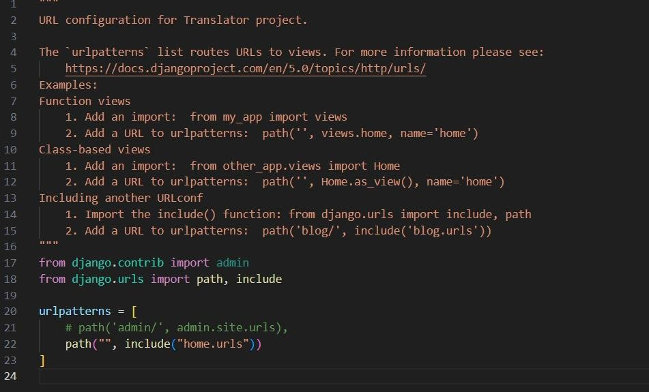

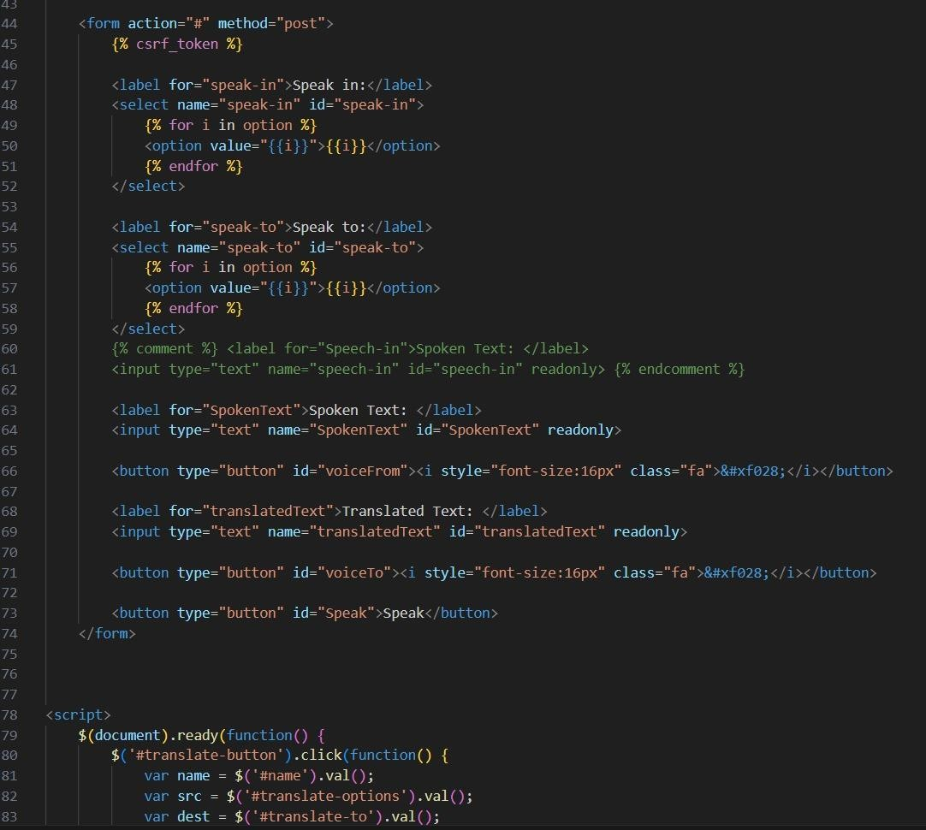

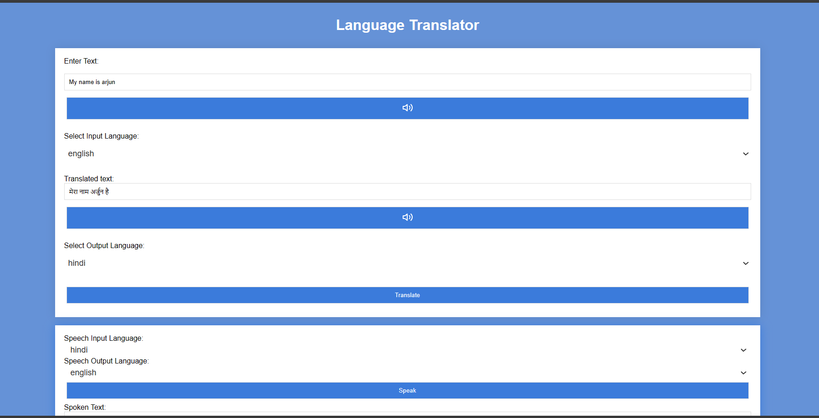

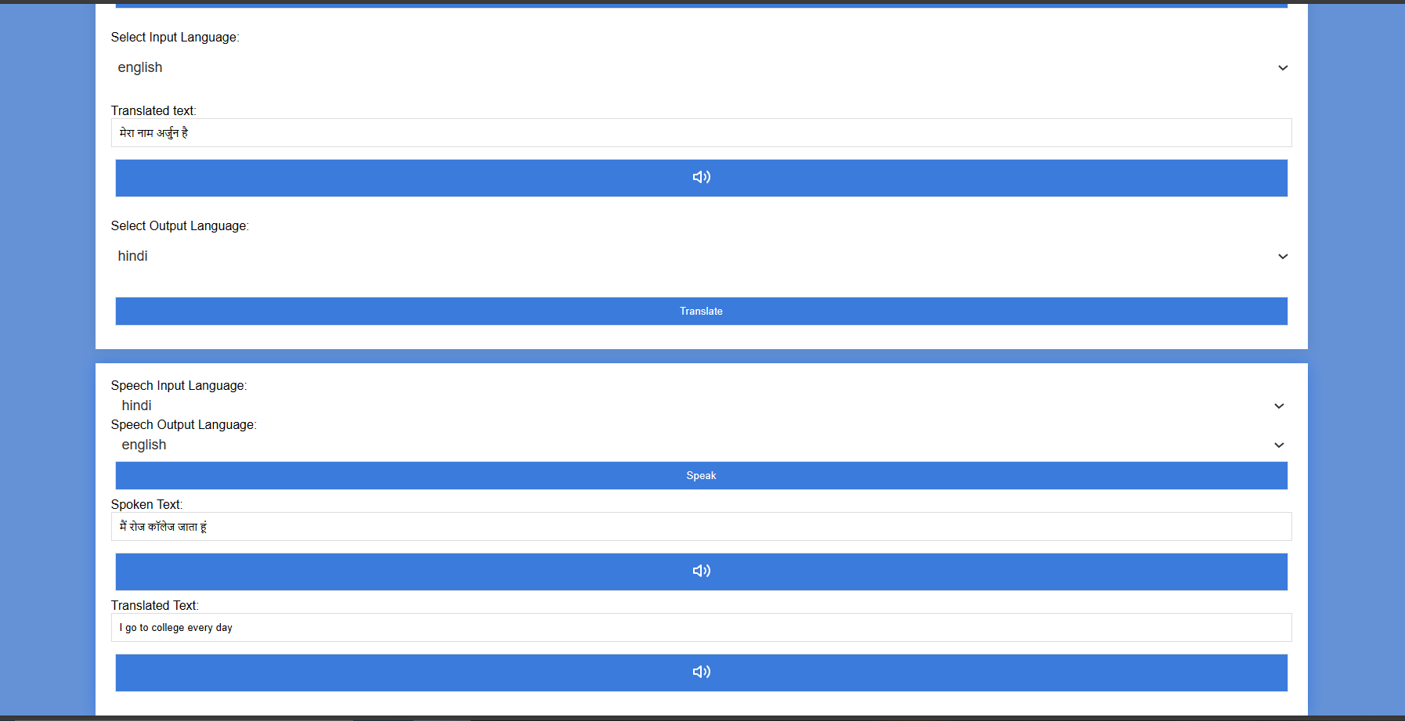

CONCLUSION

The development of this language translator tool has the potential to significantly impact communication across language barriers. By leveraging modern web technologies and established translation services, the tool offers a user-friendly and efficient solution for translating spoken and written text.

### Key Strengths:

* **Convenience:** Accessible from any web browser, eliminating software installation and facilitating on-the-go translation.
* **Efficiency:** Speech recognition (optional) streamlines translation of spoken language, saving time and effort.
* **Accuracy:** Utilises established translation services (like Google Translate) to provide reliable results.
* **Ease of Use:** Features an intuitive interface with clear instructions and user-friendly controls.

### Future Enhancements:

* **Expanded Language Support:** Integrate a wider range of languages to cater to a more diverse user base.
* **Advanced Speech Recognition:** Implement advanced speech recognition models for increased accuracy, especially with complex accents or background noise.
* **Text Input Option:** Allow users to directly input text for translation alongside audio input, providing flexibility.
* **Offline Functionality:** Explore options for offline translation capabilities, ensuring accessibility even in areas with limited internet connectivity.
* **Customization:** Allow users to define preferences for translation accuracy or language formality (potential future feature).

### Overall Impact:

This language translator tool serves as a valuable asset in overcoming language barriers. It promotes communication and understanding across diverse language groups, facilitating collaboration, information exchange, and cultural exchange. By incorporating the proposed enhancements, the tool can become even more comprehensive and cater to a broader range of users and scenarios.

### Looking Forward:

The development of this language translator tool is a starting point. As technology continues to evolve, so too can this tool. Future advancements in machine translation, speech recognition, and user interface design can be integrated to further enhance its capabilities and impact. Ultimately, this tool strives to contribute to a more connected and language-inclusive world.

REFERENCES

1. *Autenrieth, T. 2002. Heterosemie und Grammatikalisierung bei Modalpartikeln. Tübingen: Max Niemeyer.*
2. *Brinton, L.J. and E.C. Traugott. 2005. Lexicalization and Language Change. Cambridge: Cambridge University Press.*
3. *Burkhardt, A. 1995. Zur Übersetzbarkeit von Abtönungspartikeln (on the translatability of modal particles). Zeitschrift für Germanistische Linguistik, 23:2. 172- 201.*
4. *Connolly, J.H., A. Chamberlain and I.W. Phillips. 2008. An Approach to Context in Human-Computer Communication. Semiotica, 169. 45-70.*
5. *Diewald, G. 2002. A Model for Relevant Types of Contexts in Grammaticalization. In: I. Wischer and G. Diewald (eds), New Reflections on Grammaticalization. Amsterdam: John Benjamins. 103- 120.*
6. *Diewald, G. 2007. Abtönungspartikel (downtoning particles). In: L. Hoffmann (ed.), Handbuch der Deutschen Wortarten (handbook of German word classes). Berlin: Walter de Gruyter. 117-141.*
7. *Hoffmann (ed.), Handbuch der Deutschen Wortarten (handbook of German word classes). Berlin: Walter de Gruyter. 117-141.*
8. *Feyrer, C. 1998. Modalität in Kontrast (modality in contrast). Frankfurt/Main: Peter Lang.*
9. *Franck, D. 1980. Grammatik und Konversation (grammar and conversation). Königstein/Taunus: Scriptor.*
10. *Goodwin, C. and A. Duranti. 1992. Rethinking Context: An Introduction. In: A. Duranti and C. Goodwin (eds), Rethinking Context: Language as An Interactive Phenomenon. Cambridge: Cambridge University Press. 1-42*
11. *Pramudita, Y. D., Putro, S. S., Wahyudi, R. N., Suzanti, I. O., & Solihin, F. (2020). RESTful Web Service for Madurese and Indonesian Language Translator Applications on Android Devices. 2020 6th Information Technology International Seminar (ITIS). doi:10.1109/itis50118.2020.9320992*
12. *Priya, L., Sathya, A., & Raja, S. K. S. (2020). Indian and English Language to Sign Language Translator- an Automated Portable Two Way Communicator for Bridging Normal and Deprived Ones. 2020 International Conference on Power,*